Data preprocessing:

Certainly! Here’s a Python cheat sheet for the essential functions used in data preprocessing for machine learning, including the libraries needed and examples for reading and storing a .csv file. I’ll cover each of the topics you mentioned.

**Libraries Required**

import pandas as pd

import numpy as np

import seaborn as sns

import matplotlib.pyplot as plt

from sklearn.model_selection import train_test_split

from sklearn.preprocessing import StandardScaler, MinMaxScaler, OneHotEncoder, LabelEncoder

**1. Handling Missing Data**

pythonCopy code

# Load data

df = pd.read_csv('data.csv')

# Check missing values

df.isnull().sum()

# Drop rows with missing values

df.dropna(inplace=True)

# Fill missing values with mean of the column

df.fillna(df.mean(), inplace=True)

# Numerical columns: impute with mean

numerical_cols = df.select_dtypes(include=['int64', 'float64']).columns

# Categorical columns: impute with most frequent

categorical_cols = df.select_dtypes(include=['object']).columns

# Impute missing values

for col in numerical_cols:

    df[col].fillna(df[col].mean(), inplace=True)

**2. Formatting Date Columns**

# Convert a column to datetime

df['date_column'] = pd.to_datetime(df['date_column'])

# Extract year, month, day, etc.

df['year'] = df['date_column'].dt.year

df['month'] = df['date_column'].dt.month

df['day'] = df['date_column'].dt.day

**3. Visualising Dataset Before and After Handling Missing Values**

# Before

sns.heatmap(df.isnull(), cbar=False)

plt.show()

# After handling missing data

df.fillna(df.mean(), inplace=True)

sns.heatmap(df.isnull(), cbar=False)

plt.show()

**4. Handling Outliers Using IQR**

# Calculate IQR

Q1 = df['column'].quantile(0.25)

Q3 = df['column'].quantile(0.75)

IQR = Q3 - Q1

# Filter out outliers

df = df[(df['column'] >= (Q1 - 1.5 * IQR)) & (df['column'] <= (Q3 + 1.5 * IQR))]

for multiple columns:

for col in numerical_cols:

    if col != 'type':  # 'type' is now encoded, no longer numerical

        Q1 = df[col].quantile(0.25)

        Q3 = df[col].quantile(0.75)

        IQR = Q3 - Q1

        lower_bound = Q1 - 1.5 * IQR

        upper_bound = Q3 + 1.5 * IQR

        df[col] = df[col].clip(lower=lower_bound, upper=upper_bound)

**5. Visualising Outliers Before and After Preprocessing**

# Before

sns.boxplot(x=df['column'])

plt.show()

# After removing outliers

filtered_df = df[(df['column'] >= (Q1 - 1.5 * IQR)) & (df['column'] <= (Q3 + 1.5 * IQR))]

sns.boxplot(x=filtered_df['column'])

plt.show()

**6. Categorical Encoding - One Hot and Label**

# One Hot Encoding

df_encoded = pd.get_dummies(df, columns=['categorical_column'])

# Label Encoding

label_encoder = LabelEncoder()

df['categorical_column'] = label_encoder.fit_transform(df['categorical_column'])

**7. Feature Scaling - Standardisation, Normalisation**

# Standardisation

scaler = StandardScaler()

df['scaled_column'] = scaler.fit_transform(df[['numeric_column']])

# Normalisation

min_max_scaler = MinMaxScaler()

df['normalized_column'] = min_max_scaler.fit_transform(df[['numeric_column']])

**8. Splitting the Dataset into Test and Train**

# Split dataset

X_train, X_test, y_train, y_test = train_test_split(df.drop('target_column', axis=1), df['target_column'], test_size=0.2, random_state=42)

**Reading and Storing a .csv File**

# Reading a CSV file

df = pd.read_csv('data.csv')

# Storing a DataFrame as a CSV file

df.to_csv('processed_data.csv', index=False)

Regression:

**Libraries Required**

import pandas as pd

import numpy as np

import matplotlib.pyplot as plt

import seaborn as sns

import statsmodels.api as sm

from sklearn.linear_model import LinearRegression

**1. Produce Scatterplots for Each Independent Variable Against the Dependent Variable (Price)**

# Assuming 'price' is the dependent variable and others are independent variables

independent_vars = df.columns.drop('price')  # Adjust based on your dataset

for var in independent_vars:

    sns.scatterplot(x=df[var], y=df['price'])

    plt.title(f'Scatterplot of {var} vs Price')

    plt.xlabel(var)

    plt.ylabel('Price')

    plt.show()

**2. Interpret the Strength of the Relationship Via the Correlation Matrix**

# Calculate correlation matrix

correlation_matrix = df.corr()

# Plot heatmap of correlation matrix

sns.heatmap(correlation_matrix, annot=True, cmap='coolwarm')

plt.title('Correlation Matrix')

plt.show()

**3. Fit a Linear Model to the Data to Predict the Prices of Avocados Using Linear Regression**

lin_reg = LinearRegression()

lin_reg.fit(X_train, y_train)

from sklearn.metrics import mean_squared_error, r2_score

y_pred_train = lin_reg.predict(X_train)

y_pred_test = lin_reg.predict(X_test)

print('Train R-squared:', r2_score(y_train, y_pred_train))

print('Test R-squared:', r2_score(y_test, y_pred_test))

print('Train MSE:', mean_squared_error(y_train, y_pred_train))

print('Test MSE:', mean_squared_error(y_test, y_pred_test))

**4. Assess the Strength of the Relationship Through statsmodels.summary()**

import statsmodels.api as sm

X_train_sm = sm.add_constant(X_train)

model = sm.OLS(y_train, X_train_sm).fit()

print(model.summary())

**5. Based on the Scatterplots and Correlation Values, Identify Which Variable(s) You Will Use to Predict the Price of Avocados**

# Method 2: Correlation Matrix Analysis

correlation_matrix = train_df.corr()

correlation_with_target = correlation_matrix['AveragePrice'].sort_values(ascending=False)

correlation_with_target = correlation_with_target.drop('AveragePrice')

print("Correlation matrix:\n", correlation_with_target)

# Determine thresholds based on percentiles

# For positive correlations

positive_threshold = correlation_with_target[correlation_with_target > 0].quantile(0.75)

# For negative correlations

negative_threshold = correlation_with_target[correlation_with_target < 0].quantile(0.25)

# Select variables that are highly positively and negatively correlated based on these thresholds

highly_positively_correlated_vars = correlation_with_target[correlation_with_target > positive_threshold].index.tolist()

highly_negatively_correlated_vars = correlation_with_target[correlation_with_target < negative_threshold].index.tolist()

# Output the selected variables

print("Highly positively correlated variables:", highly_positively_correlated_vars)

print("Highly negatively correlated variables:", highly_negatively_correlated_vars)

import statsmodels.api as sm

# Assuming X_train and y_train are already defined and preprocessed

X_train_sm = sm.add_constant(X_train)  # Adding a constant for the intercept

model = sm.OLS(y_train, X_train_sm).fit()

# Select significant variables based on p-value < 0.05

significant_vars = list(model.pvalues[model.pvalues < 0.01].index)

if 'const' in significant_vars:

    significant_vars.remove('const')  # Remove the constant

# Print the names of the significant variables and their p-values

print("Significant variables and their p-values:")

for var in significant_vars:

    print(f"{var}: p-value={model.pvalues[var]}")

# Combine lists from correlation analysis and OLS summary

final_vars = list(set(highly_positively_correlated_vars + highly_negatively_correlated_vars + significant_vars ))

print(final_vars)

**6. Use the Appropriate Independent Variables and Fit a Linear Model**

# Fit a linear model using only the selected variables

X_train_final = X_train[final_vars]

X_test_final = X_test[final_vars]

lin_reg_final = LinearRegression()

lin_reg_final.fit(X_train_final, y_train)

# Predict and evaluate the final model using test data

y_pred_final = lin_reg_final.predict(X_test_final)

# Calculate metrics for the new model

mse_final = mean_squared_error(y_test, y_pred_final)

r2_final = r2_score(y_test, y_pred_final)

print(f'New Final model MSE: {mse_final}')

print(f'New Final model R-squared: {r2_final}')

**Visualize the Results**

# Create a scatter plot of actual vs. predicted values

plt.figure(figsize=(10, 6))

plt.scatter(y_test, y_pred_final, alpha=0.3)

# Plot a line of perfect prediction

min_val = min(y_test.min(), y_pred_final.min())

max_val = max(y_test.max(), y_pred_final.max())

plt.plot([min_val, max_val], [min_val, max_val], color='red', linestyle='--', lw=2)

plt.title('Actual vs. Predicted Prices')

plt.xlabel('Actual Prices')

plt.ylabel('Predicted Prices')

plt.show()

**LOGISTIC REGRESSION:**

**Fit model and confusion matrix**

from sklearn.linear_model import LogisticRegression

from sklearn.metrics import confusion_matrix, classification_report

# Creating a pipeline that first scales the data then applies logistic regression

pipeline = Pipeline([

    ('scaler', StandardScaler()),

    ('logistic', LogisticRegression(solver='liblinear', max_iter=1000))

])

# Fitting the model using the pipeline. The pipeline will first transform the data using StandardScaler and then fit the logistic regression model.

pipeline.fit(X_train, y_train)

# You can access the logistic regression model directly via pipeline.named_steps['logistic']

logistic_model = pipeline.named_steps['logistic']

# The model is now fitted and can be used to make predictions on the scaled test data automatically

y_pred = pipeline.predict(X_test)

# Generating the confusion matrix

cm = confusion_matrix(y_test, y_pred)

# Visualizing the confusion matrix

plt.figure(figsize=(8, 6))

sns.heatmap(cm, annot=True, fmt="d", cmap="Blues", xticklabels=['Predicted 0', 'Predicted 1'], yticklabels=['Actual 0', 'Actual 1'])

plt.title('Confusion Matrix')

plt.ylabel('Actual label')

plt.xlabel('Predicted label')

plt.show()

**precision, recall and f1**

# Classification Report for precision, recall, and F1 score

print(classification_report(y_test, y_pred, target_names=['No Rain', 'Rain']))

# Calculating and Displaying Specificity and Classification Error

tn, fp, fn, tp = cm.ravel()

specificity = tn / (tn + fp)

classification_error = (fp + fn) / (tp + tn + fp + fn)

print(f"Specificity: {specificity:.2f}")

print(f"Classification Error: {classification_error:.2f}")

**ROC curve:**

from sklearn.metrics import roc_curve, auc

import matplotlib.pyplot as plt

# Assuming `pipeline` is your fitted model and it can predict probabilities

# Get the scores (probabilities) of the positive class

y_scores = pipeline.predict_proba(X_test)[:, 1]

# Generate ROC curve values: false positive rates, true positive rates

fpr, tpr, thresholds = roc_curve(y_test, y_scores)

# Calculate Area Under the Curve (AUC)

roc_auc = auc(fpr, tpr)

# Plotting

plt.figure(figsize=(8, 6))

plt.plot(fpr, tpr, color='darkorange', lw=2, label='ROC curve (area = %0.2f)' % roc_auc)

plt.plot([0, 1], [0, 1], color='navy', lw=2, linestyle='--')

plt.xlim([0.0, 1.0])

plt.ylim([0.0, 1.05])

plt.xlabel('False Positive Rate')

plt.ylabel('True Positive Rate')

plt.title('Receiver Operating Characteristic (ROC)')

plt.legend(loc="lower right")

plt.show()

**K fold cross validation**

from sklearn.model_selection import cross_val_score, StratifiedKFold

# Initialize Stratified K-Fold to maintain the percentage of samples for each class

kfold = StratifiedKFold(n_splits=5, shuffle=True, random_state=42)

# Perform k-fold cross-validation

# Here we use 'accuracy' as the score to evaluate. You can choose other metrics like 'roc_auc', 'f1', etc.

scores = cross_val_score(pipeline, X, y, cv=kfold, scoring='accuracy')

# Print the accuracy for each fold

print("Accuracy for each fold: ", scores)

# Print the mean accuracy across all folds

print("Mean cross-validation accuracy: ", scores.mean())

# Compare this mean accuracy to your baseline model's accuracy to check for improvement

from sklearn.dummy import DummyClassifier

# Assuming y is your target variable from the dataframe 'df'

dummy = DummyClassifier(strategy='most_frequent', random_state=42)

dummy_scores = cross_val_score(dummy, X, y, cv=kfold, scoring='accuracy')

# Print the mean accuracy for the baseline model

print("Mean baseline accuracy: ", dummy_scores.mean())

# Now you can compare it to your logistic regression model's accuracy

print("Mean logistic regression accuracy: ", scores.mean())

print("Improvement over baseline: ", scores.mean() - dummy_scores.mean())

**NAÏVE BAYES:**

from sklearn.pipeline import make_pipeline

from sklearn.preprocessing import StandardScaler

from sklearn.naive_bayes import GaussianNB

from sklearn.model_selection import train_test_split

from sklearn.metrics import confusion_matrix, classification_report

import seaborn as sns

import matplotlib.pyplot as plt

import pandas as pd

**Fitting the naive bayes model**

# Creating a pipeline that includes scaling and Gaussian Naive Bayes

pipeline = make_pipeline(StandardScaler(), GaussianNB())

# Fitting the model to the training data

pipeline.fit(X_train, y_train)

# Making predictions on the test set

y_pred = pipeline.predict(X_test)

# Evaluating the model

accuracy = accuracy_score(y_test, y_pred)

print(f"Test Accuracy: {accuracy}")

**confusion matrix**

from sklearn.metrics import confusion_matrix, classification_report

import seaborn as sns

import matplotlib.pyplot as plt

# Assuming y_test are the true labels and y_pred are the predictions made by the model

# Generating the confusion matrix

cm = confusion_matrix(y_test, y_pred)

# Visualizing the confusion matrix

plt.figure(figsize=(8, 6))

sns.heatmap(cm, annot=True, fmt="d", cmap='Blues', xticklabels=['Predicted No', 'Predicted Yes'], yticklabels=['Actual No', 'Actual Yes'])

plt.ylabel('True label')

plt.xlabel('Predicted label')

plt.title('Confusion Matrix for Naive Bayes Model')

plt.show()

**recall, f1, precision**

from sklearn.metrics import classification_report

# Generate and print the classification report for precision, recall, and F1 score

print(classification_report(y_test, y_pred, target_names=['No', 'Yes']))

# Calculate the confusion matrix to use for calculating classification error and specificity

cm = confusion_matrix(y_test, y_pred)

tn, fp, fn, tp = cm.ravel()

# Classification error (also known as Misclassification Rate)

classification_error = (fp + fn) / float(tp + tn + fp + fn)

print(f"Classification Error: {classification_error:.2f}")

# Specificity (True Negative Rate)

specificity = tn / (tn + fp)

print(f"Specificity: {specificity:.2f}")

**ROC curve**

from sklearn.metrics import roc_curve, roc_auc_score

import numpy as np

import matplotlib.pyplot as plt

# Step 1: Get the predicted probabilities for the positive class

y_scores = pipeline.predict_proba(X_test)[:, 1]

# Step 2: Calculate ROC curve and AUC score

fpr, tpr, thresholds = roc_curve(y_test, y_scores)

roc_auc = roc_auc_score(y_test, y_scores)

# Step 3: Plot ROC curve

plt.figure(figsize=(8, 6))

plt.plot(fpr, tpr, label=f'ROC curve (AUC = {roc_auc:.2f})')

plt.plot([0, 1], [0, 1], 'k--')  # Dashed diagonal

plt.xlabel('False Positive Rate')

plt.ylabel('True Positive Rate')

plt.title('ROC Curve')

plt.legend(loc='lower right')

plt.show()

**adjusting the decision threshold based on Youden's J statistic**

from sklearn.metrics import roc_curve

from sklearn.metrics import accuracy_score, precision_score, recall_score, f1_score

# Assume y_scores are the predicted probabilities for the positive class

fpr, tpr, thresholds = roc_curve(y_test, y_scores)

# Calculate Youden's J statistic

j_statistic = tpr - fpr

optimal_idx = np.argmax(j_statistic)

optimal_threshold = thresholds[optimal_idx]

print(f"Optimal Threshold based on Youden's J statistic: {optimal_threshold}")

# Step 4: Choose a new threshold from the ROC curve that suits your need

# This is a manual step depending on your specific requirement (e.g., balancing precision and recall)

# For demonstration, let's say you chose a threshold that gives you higher recall

new_threshold = optimal_threshold  # Example threshold

# Step 5: Apply the new threshold to adjust classification decisions

y_pred_adjusted = (y_scores >= new_threshold).astype(int)

# Now you can calculate metrics using the adjusted predictions to see the impact

from sklearn.metrics import accuracy_score, precision_score, recall_score, f1_score

print("Adjusted Metrics:")

print(f"Accuracy: {accuracy_score(y_test, y_pred_adjusted):.4f}")

print(f"Precision: {precision_score(y_test, y_pred_adjusted):.4f}")

print(f"Recall: {recall_score(y_test, y_pred_adjusted):.4f}")

print(f"F1 Score: {f1_score(y_test, y_pred_adjusted):.4f}")

**k-fold cross validation**

from sklearn.model_selection import cross_val_score, StratifiedKFold

from sklearn.naive_bayes import GaussianNB

from sklearn.pipeline import make_pipeline

from sklearn.preprocessing import StandardScaler

# Assuming 'X' and 'y' are your features and target variable from the preprocessed DataFrame

# Creating a pipeline with a scaler and Gaussian Naive Bayes

pipeline = make_pipeline(StandardScaler(), GaussianNB())

# Evaluating model performance with cross-validation

kfold = StratifiedKFold(n_splits=5, shuffle=True, random_state=42)

cv_scores = cross_val_score(pipeline, X, y, cv=kfold, scoring='accuracy')

print(f"CV Accuracy: {cv_scores.mean()} ± {cv_scores.std()}")

**tuning hyperparameters**

from sklearn.model_selection import GridSearchCV

from sklearn.naive_bayes import GaussianNB

from sklearn.pipeline import Pipeline

from sklearn.preprocessing import StandardScaler

# Assuming 'X' and 'y' are your features and target variable from the preprocessed DataFrame

# Creating a pipeline that includes scaling and Gaussian Naive Bayes

pipeline = Pipeline([

    ('scaler', StandardScaler()),

    ('naive_bayes', GaussianNB())

])

# Define a grid of hyperparameters to search

# For GaussianNB, we can tune the 'var_smoothing' parameter

param_grid = {

    'naive_bayes__var_smoothing': np.logspace(0, -9, num=100)

}

# Set up GridSearchCV

grid_search = GridSearchCV(pipeline, param_grid, cv=5, scoring='accuracy', verbose=1)

# Fit the GridSearchCV object to the data

grid_search.fit(X, y)

# Print the best parameters and the best score

print("Best parameters found: ", grid_search.best_params_)

print("Best cross-validation accuracy: ", grid_search.best_score_)

**Clustering:**

**K-means clustering**

import numpy as np

import matplotlib.pyplot as plt

import pandas as pd

from sklearn.preprocessing import StandardScaler, LabelEncoder

from sklearn.cluster import KMeans

**Elbow method to find number of clusters**

# Assuming you've saved the cleaned data to 'cleaned_data.csv'

data_scaled = pd.read_csv('/content/drive/MyDrive/dataset/Live_scaled.csv')

# Select features for clustering

X = data_scaled[['num_reactions', 'num_comments']].values

# Apply the Elbow Method to find the optimal number of clusters

wcss = []

for i in range(1, 11):

    kmeans = KMeans(n_clusters=i, init='k-means++', n_init=10, random_state=42)

    kmeans.fit(X)

    wcss.append(kmeans.inertia_)

plt.plot(range(1, 11), wcss)

plt.title('The Elbow Method')

plt.xlabel('Number of clusters')

plt.ylabel('WCSS')

plt.show()

**number of cluster fining using knee locator (optional)**

from kneed import KneeLocator

import matplotlib.pyplot as plt

# Number of clusters range

range_n_clusters = range(1, 11)

# Find the elbow point

knee_locator = KneeLocator(range_n_clusters, wcss, curve='convex', direction='decreasing')

# Optimal number of clusters

optimal_clusters = knee_locator.elbow

print(f"The optimal number of clusters: {optimal_clusters}")

**k-means cluster fitting**

# Perform K-means clustering

kmeans = KMeans(n_clusters=3, init='k-means++', n_init=10, random_state=42)

y_kmeans = kmeans.fit_predict(X)

# Visualize the clusters

plt.scatter(X[y_kmeans == 0, 0], X[y_kmeans == 0, 1], s=100, c='red', label='Cluster 1')

plt.scatter(X[y_kmeans == 1, 0], X[y_kmeans == 1, 1], s=100, c='blue', label='Cluster 2')

plt.scatter(X[y_kmeans == 2, 0], X[y_kmeans == 2, 1], s=100, c='green', label='Cluster 3')

# Plotting the centroids of the clusters

plt.scatter(kmeans.cluster_centers_[:, 0], kmeans.cluster_centers_[:, 1], s=300, c='yellow', label='Centroids')

plt.title('K-means Clusters of Facebook Live Sellers')

plt.xlabel('Number of Reactions')

plt.ylabel('Number of Comments')

plt.legend()

plt.show()

**Print major element in each cluster:**

# Add cluster labels to the original cleaned data (not scaled)

data_cleaned['Cluster'] = y_kmeans

# Ensure this uses the original, unscaled 'data_cleaned' with 'Cluster' labels assigned

for cluster in sorted(data_cleaned['Cluster'].unique()):

    cluster_data = data_cleaned[data_cleaned['Cluster'] == cluster]

    # Find the encoded majority status_type, ensuring to work with non-scaled, encoded values

    majority_status_encoded = cluster_data['status_type'].mode()[0]

    # Decode the majority status_type

    majority_status = label_encoder.inverse_transform([int(majority_status_encoded)])[0]

    print(f"Majority status_type in Cluster {cluster}: {majority_status}")

**HIERARCHICAL CLUSTERING:**

**dendrogram to find the optimal number of clusters**

import scipy.cluster.hierarchy as sch

import matplotlib.pyplot as plt

# Create a dendrogram

dendrogram = sch.dendrogram(sch.linkage(X, method='ward'))

plt.title('Dendrogram')

plt.xlabel('Data Points')

plt.ylabel('Euclidean Distances')

plt.show()

**Hierarchical Clustering model fitting**

from sklearn.cluster import AgglomerativeClustering

# Perform hierarchical clustering

hc = AgglomerativeClustering(n_clusters=3, affinity='euclidean', linkage='ward')

y_hc = hc.fit_predict(X)

**Visualizing the clusters**

# Visualize the clusters

plt.scatter(X[y_hc == 0, 0], X[y_hc == 0, 1], s=100, c='red', label='Cluster 1')

plt.scatter(X[y_hc == 1, 0], X[y_hc == 1, 1], s=100, c='blue', label='Cluster 2')

plt.scatter(X[y_hc == 2, 0], X[y_hc == 2, 1], s=100, c='green', label='Cluster 3')

plt.title('Clusters of Facebook Live Sellers (Hierarchical Clustering)')

plt.xlabel('Number of Reactions')

plt.ylabel('Number of Comments')

plt.legend()

plt.show()

**Majority status type in each cluster**

# Add the cluster labels to your original dataset

data['Cluster'] = y_hc

# Label encode 'status_type' to revert back to original categorical types for majority voting

label_encoder = LabelEncoder()

data['status_type_encoded'] = label_encoder.fit_transform(data['status_type'])

# Calculate the majority 'status_type' for each cluster

for i in range(3):  # assuming 3 clusters

    cluster_group = data[data['Cluster'] == i]

    majority_status = cluster_group['status_type'].value_counts().idxmax()

    print(f"Majority status_type in Cluster {i}: {majority_status}")

**Decision Tree:**

from sklearn.tree import DecisionTreeClassifier

from sklearn.metrics import accuracy_score

dt = DecisionTreeClassifier(random_state=42)

dt.fit(X_train, y_train)

y_pred_dt = dt.predict(X_test)

print(f"Decision Tree Accuracy: {accuracy_score(y_test, y_pred_dt)}")

**hyperparameter tuning**

from sklearn.model_selection import GridSearchCV

dt_param_grid = {

    'max_depth': [None, 10, 20, 30],

    'min_samples_leaf': [1, 2, 4],

    'min_samples_split': [2, 5, 10]

}

dt_grid_search = GridSearchCV(DecisionTreeClassifier(random_state=42), dt_param_grid, cv=5, scoring='accuracy')

dt_grid_search.fit(X_train, y_train)

print(f"Best parameters for Decision Tree: {dt_grid_search.best_params_}")

# Using the best estimator from the grid search

best_dt = dt_grid_search.best_estimator_

y_pred_best_dt = best_dt.predict(X_test)

print(f"Decision Tree Accuracy after tuning: {accuracy_score(y_test, y_pred_best_dt)}")

**Neural networks:**

from sklearn.neural_network import MLPClassifier

nn = MLPClassifier(random_state=42, max_iter=1000)

nn.fit(X_train, y_train)  # Ensure X_train is scaled

y_pred_nn = nn.predict(X_test)

print(f"Neural Network Accuracy: {accuracy_score(y_test, y_pred_nn)}")

**hyperparameter tuning**

nn_param_grid = {

    'hidden_layer_sizes': [(50,), (100,), (50,50), (100,100)],

    'activation': ['tanh', 'relu'],

    'solver': ['sgd', 'adam'],

    'alpha': [0.0001, 0.05],

}

nn_grid_search = GridSearchCV(MLPClassifier(random_state=42, max_iter=1000), nn_param_grid, cv=5, scoring='accuracy')

nn_grid_search.fit(X_train, y_train)

print(f"Best parameters for Neural Network: {nn_grid_search.best_params_}")

best_nn = nn_grid_search.best_estimator_

y_pred_best_nn = best_nn.predict(X_test)

print(f"Neural Network Accuracy after tuning: {accuracy_score(y_test, y_pred_best_nn)}")

**Data Preparation:**

<https://medium.com/@vaniksaras/mastering-the-art-of-data-alchemy-a-guide-to-seamless-data-preparation-11b9191dbce3>

**What is Regression?**

Regression is a statistical method used in finance, investing, and other disciplines that attempts to determine the strength and character of the relationship between one dependent variable (usually denoted by Y) and a series of other changing variables (known as independent variables). The main goal of regression is to predict or explain the dependent variable based on the independent variables. It is widely used for prediction and forecasting in many fields.

**How to Perform Regression Analysis**

Performing regression typically involves the following steps:

Data Collection: Gather the data that will be used in the prediction model.

Exploratory Data Analysis: Check how the data is distributed and identify any correlations among the data points.

Data Cleaning and Preparation: Handle missing data, outliers, and normalize the data if necessary.

Selecting the Model: Choose the type of regression model that best fits the problem.

Model Training: Train the model using a part of the dataset (training dataset).

Model Evaluation: Evaluate the model's performance using a different part of the dataset (testing dataset). Common metrics include R-squared, Root Mean Squared Error (RMSE), and Mean Absolute Error (MAE).

Model Refinement: Fine-tune the model by adjusting parameters or model configuration based on performance metrics.

Prediction: Use the model to make predictions.

**Types of Regression and Their Uses**

There are several types of regression models, each suited for different types of data and analysis needs:

**Linear Regression**

Description: Predicts a dependent variable value (y) based on a given independent variable (x). If this relationship is plotted on a 2D space, the data points should ideally form a straight line.

Use Case: Used when data points form a linearly distributable dataset, such as predicting house prices based on area or predicting salary based on experience.

**Multiple Linear Regression**

Description: Similar to linear regression, but with multiple independent variables contributing to the dependent variable’s outcome.

Use Case: Useful for more complex problems where multiple variables affect the dependent variable, like predicting a car’s mileage based on engine size, weight, and horsepower.

**Polynomial Regression**

Description: Extends linear regression by adding terms with powers greater than one, making it suitable for non-linear data sets.

Use Case: Used when the data points form a curve rather than a straight line, such as the growth rate of tissues or the progression of disease epidemics.

**Logistic Regression**

Description: Despite its name, it’s a linear model for classification rather than regression. It predicts a probability that Y belongs to a certain category.

Use Case: Commonly used for binary classification tasks, like spam detection or predicting if a student will pass or fail based on their hours of study.

**Ridge Regression**

Description: A type of regularized linear regression that includes a penalty term to reduce model complexity and prevent overfitting.

Use Case: Useful when the data includes multicollinearity or when you have more features than data points.

**Lasso Regression**

Description: Similar to Ridge Regression but with a different penalty term that can reduce the number of features in the final model by assigning zero coefficients to less important features.

Use Case: Ideal for models that benefit from feature selection in case of high dimensionality.

**Elastic Net Regression**

Description: Combines penalties of Ridge and Lasso regression to provide a balanced approach to regularizing complex models.

Use Case: Used when there are several highly correlated variables, effectively balancing between parameter penalty and model complexity.

**Linear classification:**

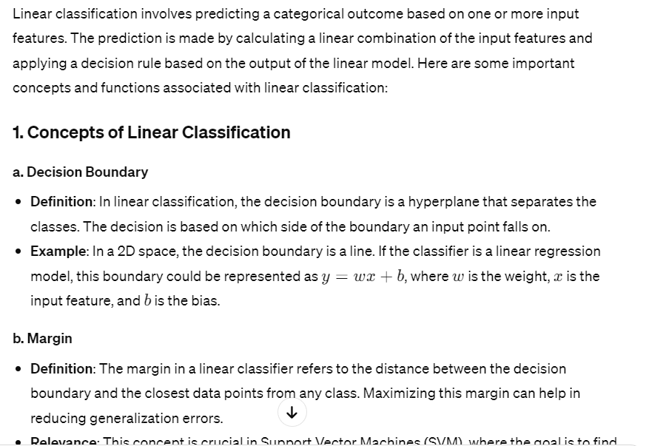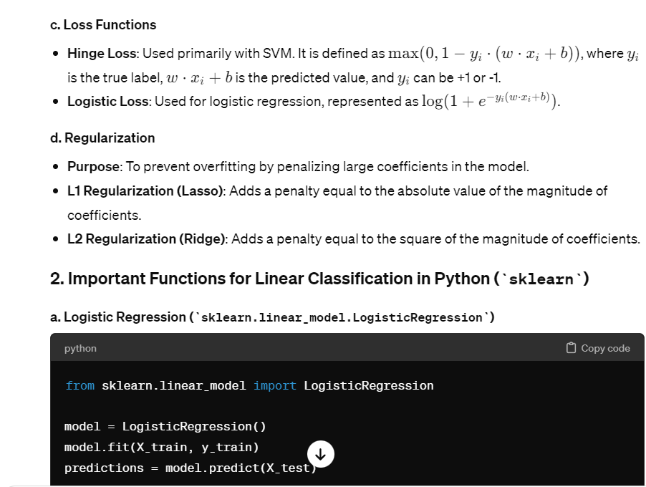

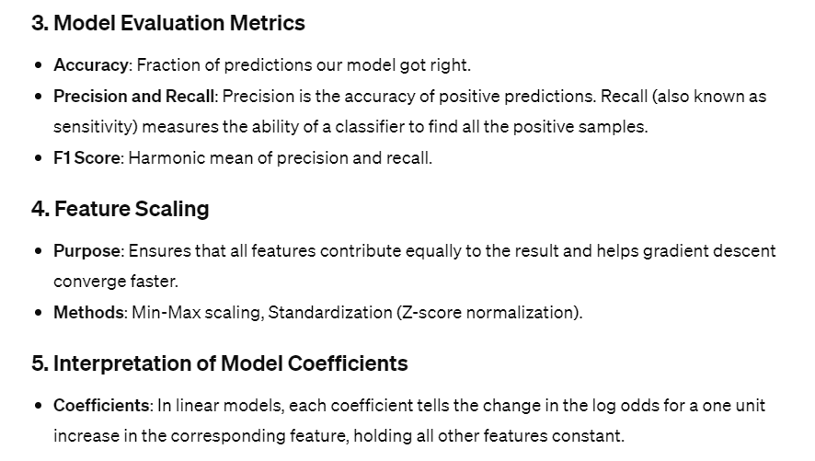

**K means clustering**

